Lab # 10

wRAPPER CLASSES, SCANNER CLASS AND ARRAY CLASS

OBJECTive:
To get familiar with wrapper classes; Scanner class, and Array class.

THEORY:

10.1 WRAPPER CLASSES IN JAVA
A Wrapper class is a class whose object wraps or contains a primitive data types. When we create an object to a wrapper class, it contains a field and in this field, we can store a primitive data types. In other words, we can wrap a primitive value into a wrapper class object.
Need of Wrapper Classes:

- They convert primitive data types into objects. Objects are needed if we wish to modify the arguments passed into a method (because primitive types are passed by value).
- The classes in java.util package handles only objects and hence wrapper classes help in this case also.
- Data structures in the Collection framework, such as ArrayList and Vector, store only objects (reference types) and not primitive types.
- An object is needed to support synchronization in multithreading.

Primitive Data types and their Corresponding Wrapper class

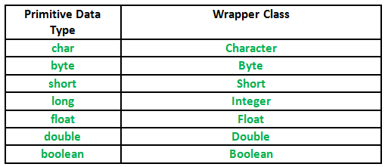

The following program demonstrate the above mentioning description about wrapper class.

// Java program to demonstrate Wrapping and UnWrapping
// in Java Classes
class WrappingUnwrapping
{
public static void main(String args[])
{
// byte data type
byte a = 1;

// wrapping around Byte object
Byte byteobj = new Byte(a);

// int data type
int b = 10;

//wrapping around Integer object
Integer intobj = new Integer(b);

// float data type
float c = 18.6f;

// wrapping around Float object
Float floatobj = new Float(c);

// double data type
double d = 250.5;

// Wrapping around Double object
Double doubleobj = new Double(d);

// char data type
char e='a';

// wrapping around Character object
Character charobj=e;

// printing the values from objects
System.out.println("Values of Wrapper objects (printing as objects)");
System.out.println("Byte object byteobj: " + byteobj);
System.out.println("Integer object intobj: " + intobj);
System.out.println("Float object floatobj: " + floatobj);
System.out.println("Double object doubleobj: " + doubleobj);
System.out.println("Character object charobj: " + charobj);

// objects to data types (retrieving data types from objects)
// unwrapping objects to primitive data types
byte bv = byteobj;
int iv = intobj;
float fv = floatobj;
double dv = doubleobj;
char cv = charobj;

// printing the values from data types
System.out.println("Unwrapped values (printing as data types)");
System.out.println("byte value, bv: " + bv);
System.out.println("int value, iv: " + iv);
System.out.println("float value, fv: " + fv);
System.out.println("double value, dv: " + dv);
System.out.println("char value, cv: " + cv);
}
}

Output:

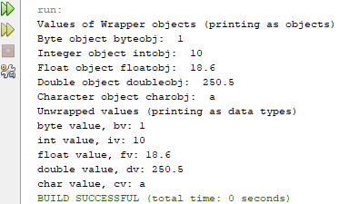

Byte, Short, Integer, and Long:

The Byte, Short, Integer, and Long classes are wrappers for byte, short, int, and long integer types, respectively. Their constructors are shown here:

Byte(byte num) Byte(String str) throws NumberFormatException

Short(short num) Short(String str) throws NumberFormatException

Integer(int num) Integer(String str) throws NumberFormatException

Long(long num) Long(String str) throws NumberFormatException

The throw keyword in Java is used to explicitly throw an exception from a method or any block of code. We can throw either checked or unchecked exception. The throw keyword is mainly used to throw custom exceptions, this will be explained in detail later.

As you can see, these objects can be constructed from numeric values or from strings that contain valid whole number values. The methods defined by these classes are shown in given Table. They define methods for converting strings back into integers. Variants of these methods allow you to specify the radix, or numeric base, for conversion. Common radixes are 2 for binary, 8 for octal, 10 for decimal, and 16 for hexadecimal. The following constants are defined:
MIN_VALUE Minimum value
MAX_VALUE Maximum value
TYPE The Class object for byte, short, int, or long

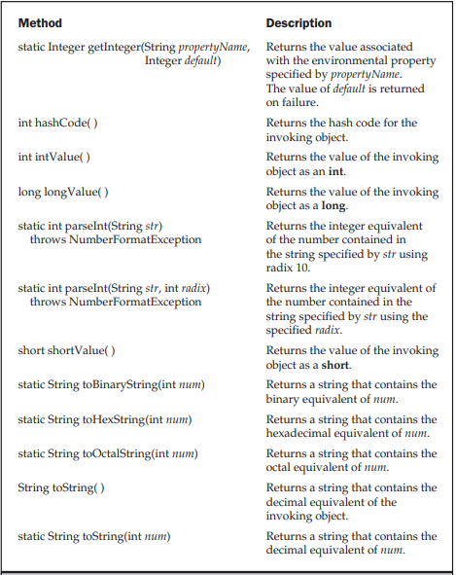

Character Class:

The Character class of the java.lang package wraps a value of the primitive datatype char. It offers a number of useful class (i.e., static) methods for manipulating characters. You can create a Character object with the Character constructor.

Following are the notable methods of the Character class.

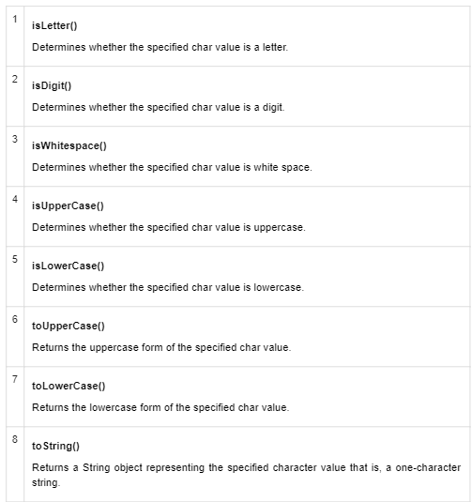

class CharacterClassExample {
public static void main(String[] args) {
char ch1, ch2;
ch1 = '9';
ch2 = 'V';

boolean b1, b2;
b1 = Character.isDigit(ch1);
b2 = Character.isDigit(ch2);

String str1 = ch1 + " is a digit is " + b1;
String str2 = ch2 + " is a digit is " + b2;
System.out.println( str1 );
System.out.println( str2 );
}
}

Output:

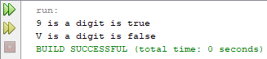

10.2 SCANNER CLASS

The java.util.Scanner class defines objects that use regular expressions to scan character input from a variety of sources and present the input as a sequence of tokens of various primitive types or as strings. For example, you can use a Scanner object to read data values of various types from a file or a stream, including the standard stream System.in.

Creating Scanner Objects:

You can create a Scanner object by passing an object encapsulating the source of the data to be scanned to a Scanner constructor.

Let’s take the obvious example of a source from which you might want to interpret data. To obtain a Scanner object that will scan input from the keyboard, you could use the following statement:

java.util.Scanner keyboard = new java.util.Scanner(System.in);

Scanner Class Methods:

Below is a list of some of the methods of the Scanner class.

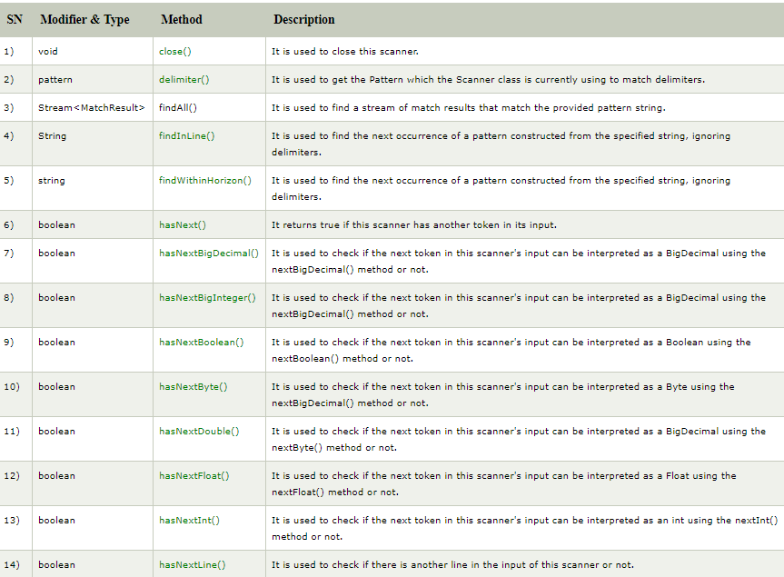
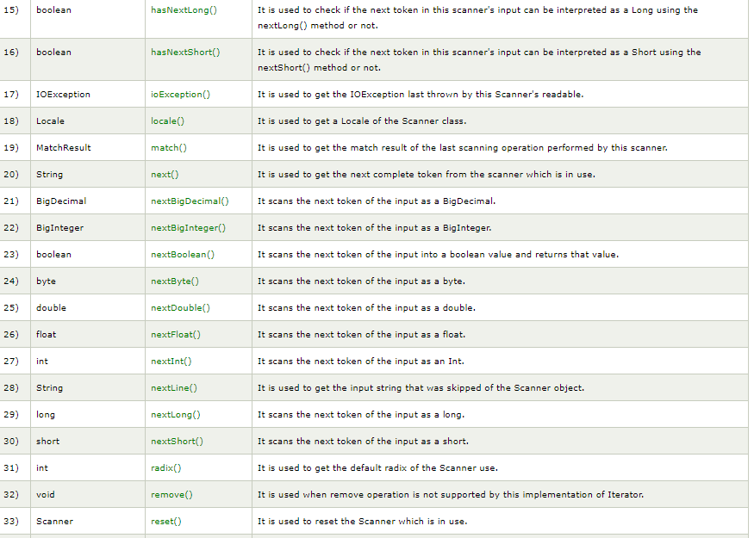

Using a Scanner:
Here’s a simple example that just reads a variety of input from the standard input stream and displays what was read:

import java.util.Scanner;
class TryScanner {
public static void main(String[] args) {
Scanner kbScan = new Scanner(System.in); // Create the scanner
int selectRead = 1; // Selects the read operation
int MAXTRIES = 3; // Maximum attempts at input
int tries = 0; // Number of input attempts
while(tries<MAXTRIES) {
switch(selectRead) {
case 1:
System.out.println("Enter an Integer:");
System.out.println("You entered: "+ kbScan.nextLong());
++selectRead; // Select next read operation
tries = 0; // Reset count of tries
case 2:
System.out.print("Enter a floating-point value: ");
System.out.println("You entered: "+ kbScan.nextDouble());
++selectRead; // Select next read operation
tries = 0; // Reset count of tries
case 3:
System.out.print("Enter a boolean value(true or false): ");
System.out.println("You entered: "+ kbScan.nextBoolean());
}
break;
}
}
}

Output:

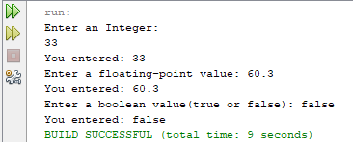

10.3 ARRAYS CLASS

The Arrays class in java.util package is a part of the Java Collection Framework. This class provides static methods to dynamically create and access Java arrays. It consists of only static methods and the methods of Object class. The methods of this class can be used by the class name itself.

class Hierarchy:
java.lang.Object
↳ java.util.Arrays
Class Declaration:
public class Arrays
extends Object
Syntax to use Array:
Arrays.<function name>;

Need for the Java-Arrays Class:
There are often times when loops are used to do some tasks on an array like:
- Fill an array with a particular value.
- Sort an Arrays.
- Search in an Arrays.
- And many more.
Arrays class provides several static methods that can be used to perform these tasks directly without the use of loops.

Methods in Java Array:
The Arrays class of the java.util package contains several static methods that can be used to fill, sort, search, etc in arrays. These are:

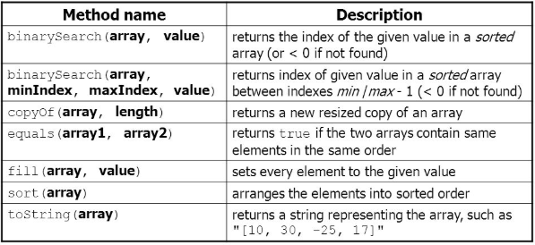

Following program is for returning a fixed-size list backed by the specified Arrays using Arrays.asList().

// Java program to demonstrate
// Arrays.asList() method

import java.util.Arrays;

public class Main {
public static void main(String[] args)
{

// Get the Array
int intArr[] = { 10, 20, 15, 22, 35 };

// To convert the elements as List
System.out.println("Integer Array as List: "
+ Arrays.asList(intArr));
}
}

Output:

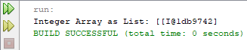

LAB TASK

- Write a program to take the integer value from the user and convert an integer into binary, hexadecimal, and octal with the help of methods defined in wrapper class of Integer and Long.

- Write a program to display the sign of the Zodiac corresponding to a birth date entered through the keyboard.

- Write a program to take 10 integer values from the user and display the odd values with their indexes and copy of the original array by using the search and copy method respectively, define in array class.

Example:
Array= {11,22,33,44,55,66,77,88,99,111}

Sample Output:
11 found at index= 1
33 found at index= 3
55 found at index= 5
77 found at index= 7
111 found at index= 9

Array= {11,22,33,44,55,66,77,88,99,111}

